Mulesoft Execute Store Procedures

1. Store Procedure in database.

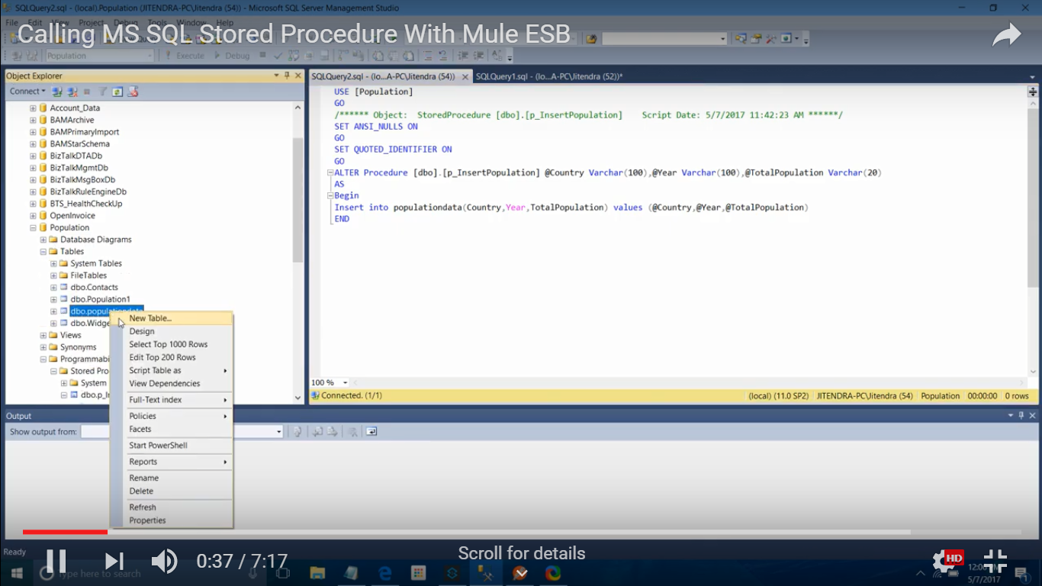

2. Select "Generic Database Configuration"

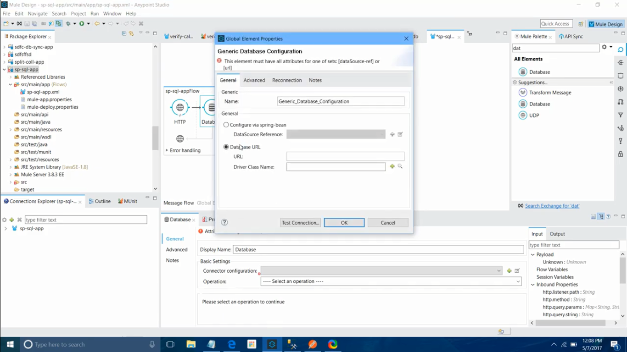

3. Value URL & Driver Class Name

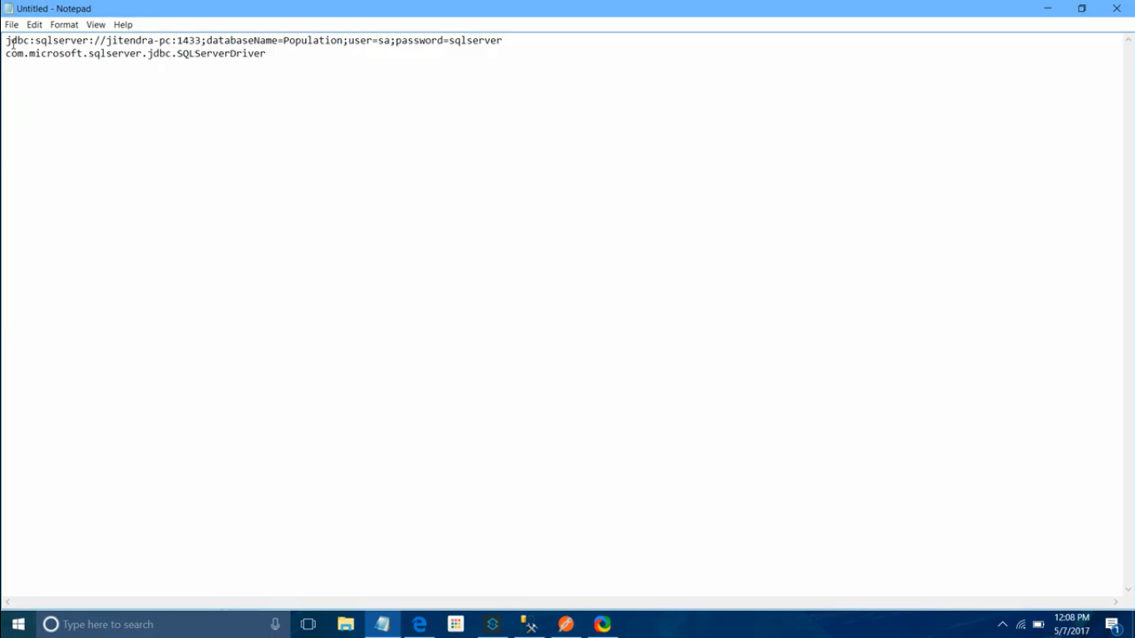

4. Store procedure command in connector

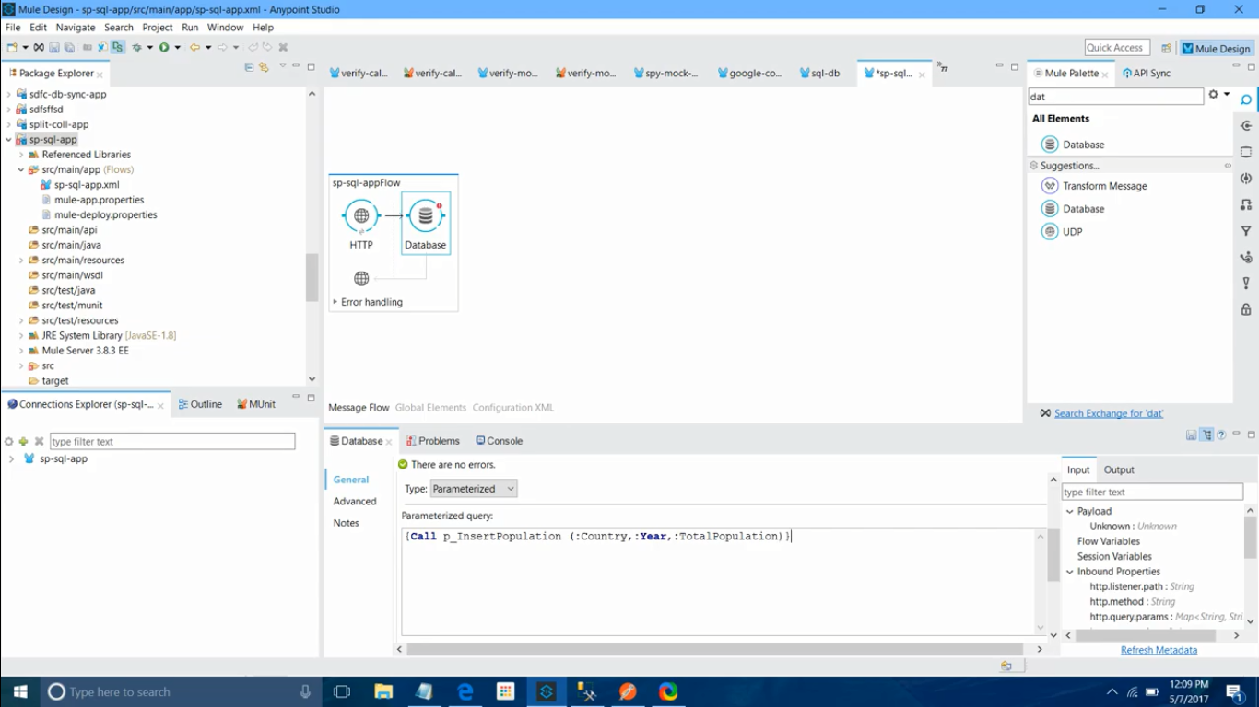

5. Input mappings for the store procedures

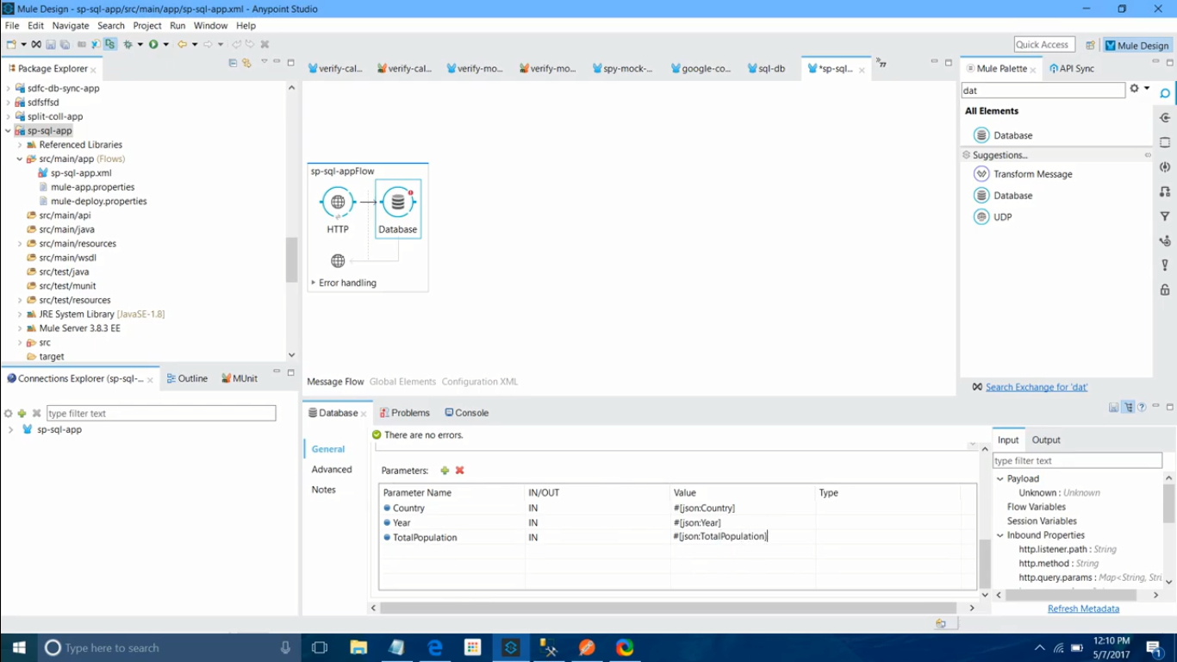

6.